General Course Information

Course Title | Art 1
Description | This course is designed as an introduction to art making and creative thinking. Students will develop the discipline of creative thinking and problem solving through regular class challenges and sketchbook activities. We will also practice art-making and composition techniques, principles, and concepts through a variety of techniques, methods and media, exposing students to a variety of artistic experiences.  Mediums explored will include collage, drawing, painting, sculpture, ceramics and more. Emphasis will also be placed on exploring contemporary and historical art and artists. Students will work towards visual literacy: making and considering art that expresses ideas and opinion through visual means.
Room Number | 107
Faculty Name | Ms. Brown
Contact Information | 517-545-0828  rbrown@kwoods.org
Course Website | www.rbrown.kwoods.org
Introduction
Art communicates ideas through a medium.
Again, this course is designed as an introduction to art making and creative thinking.

Whether planning to pursue art beyond high school, or rather just for enjoyment, art provides us a new way of seeing and thinking about our surroundings. Making art provides us with a way to express our ideas and feelings in unique ways. Examining art and its history provides us a way to understand what happened in the world in the past and present.

In this course, you will work towards Michigan’s Merit Curriculum standards in the visual arts by developing ways to think critically about art and become more creative as well as learn about techniques, principles and concepts in a variety of art media. This course also meets Kensington Woods High School and the Michigan Merit Curriculum art credit graduation requirement.
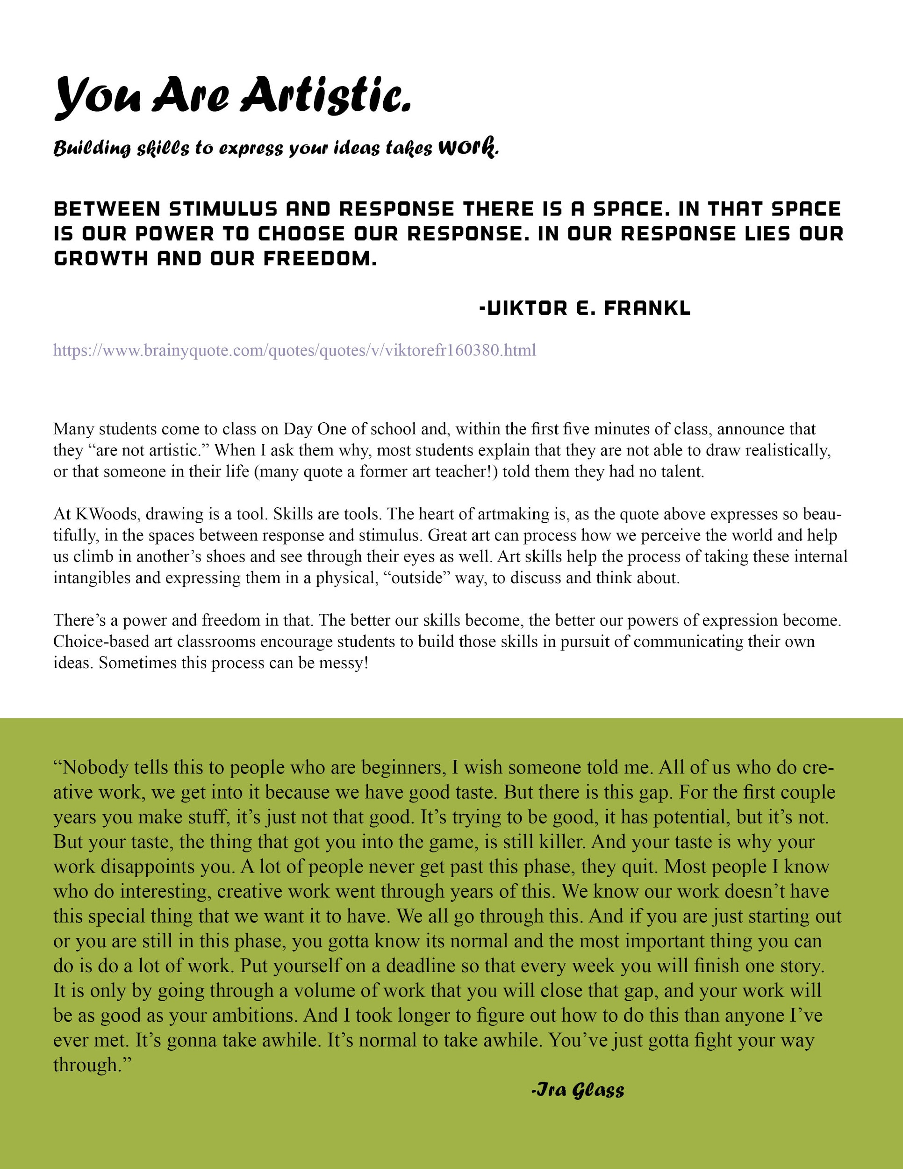

Course Expectations

You are expected to work hard and try your best. You are also expected to be respectful and responsible students inside and outside of the art classroom (studio). This includes respectful and responsible behavior towards your class work, classmates, me and classroom.

Students are expected to keep up with projects and assignments that will be worked on daily in class as well as with work that may be needed to be done outside of class. Class work will be consisted of daily activities and longer-term projects where students will learn about and practice concepts and techniques required of them. Class time will also consist of class discussions about artwork (students’ and working artists) as well as discussions about art and contemporary issues. Students are expected to be active participants in all discussions and will be held responsible accordingly. At times, work may need to be completed or worked on outside of class, and students will be expected to complete the work as necessary. Students will also be assigned sketchbook assignments that will be due at regular intervals of the semester that should be completed at home or in class when finished with other projects.

To be successful with this class, you must work continually. It is very easy to leave larger projects until the last minute, but art making is a process. It takes time to evolve ideas and techniques and by working continually on your projects and sketchbooks, you will find yourself a much more successful artist.

Studio Environment
I expect you to challenge yourself with your ideas and not be afraid to take risks. It’s ok if an artwork doesn’t work the first time. Things can be revised, modified and improved through reflection and effort and the artwork can become successful. I feel the most important part of making an artwork is not the end result but the process of making the work. The studio should be a safe place for all artists, so you are expected to be respectful and constructive with your comments about others’ work. Everybody enters this classroom with different experiences and ability levels and it is the goal of this class to improve you to the best of your ability. Everybody can learn how to do the things we will do in this classroom and be successful as long as they put forth their ideas, a positive attitude and effort. Although art is a visual medium, your ideas are equally important to your technique.

Technology in the Classroom
In this class we will use various types of technology to help us research, share ideas and reflect. This includes, but is not limited to: internet use, email, Google programs and video. When technology based assignments are given, students will be expected to complete them on time and make plans accordingly if internet access is not available at home. Students will be provided with access to any technology needed to complete the requirements of this course through Kensington Woods High School.

Prerequisite knowledge/skills for success in this course

Students do not need to have any prior experience in art to find success in this course. Instead, students are expected to work thoughtfully and purposefully, developing their technical, conceptual and aesthetic skills throughout the year.

Students will also work on developing the following skills that will help them find success in this course.

Mastery Level | Work habits: Students will be able to work effectively independently and in groups. Students will be able to work thoughtfully and with purpose.  Academic integrity: Students will act honestly and ethically in their work.  Study skills: Students will adhere to assignment deadlines.  Reflection: Students will be able to reflect about their own and others work in and thoughtful and purposeful manner.  Technology (both manual and computer based): Students will develop a deep understanding of technologies used in class
Familiarity Level | Research: Students will develop research skills (computer and book based) to research artists and artwork  Technology (both manual and computer based): Students will develop familiarity with technologies used in class  Art History and Context: Student will develop skills in analyzing art and placing art in context

Grading

At the beginning of each unit, students will be given an outline of standards-based mastery objectives to be gained throughout the project. Objectives will be divided into two categories: essential, and above-and-beyond. Students who meet the baseline objectives will pass the class, and those who put forward the effort to demonstrate the full list of objectives will earn an A.

KWHS follows the following grading scale:

A= 95-100 (4.0)
A- = 90-94 (3.7)
B+ = 87-89 (3.3)
B = 83-36 (3.0)
B- = 80-82 (2.7)
C+ = 77-79 (2.3)
C = 73-76 (2.0)
C- = 70-72 (1.6)
F = below 70 (0.0)

Your grade will consist of assessment of the following:
80% Summative Assessments (summative means assessments that sum up your learning)
Includes major projects and reflections

20% Summative Final Project/reflection
End of semester project/reflection

You and your parents can check your progress at any time using MISTAR, our online grading and record keeping program. For more information about MISTAR, visit the school’s website, www.kwoods.org.

Late Work

Students who do not submit work by the project deadline waive their right to the two-week revision window and will receive a zero on their project.

However, if you are struggling with a project, or need more time, please talk to me in advance of the due date. If you are working and putting in your best effort, the due date can be extended for you. However, know that the class will move on and you will be expected to come in and work on the project outside of class (before school, after school, lunch). I am often available during all of those times with advance notice.

Please keep in mind that you must talk to me BEFORE the due date to be granted an extension.

Revision
I expect you to put in your best effort on your work and master the content. If you do not master the content of a unit/project by receiving at least a 70% on the work, I expect that you will revise the project until you get at least a 70%. We will work on that process on a one-on-one basis if necessary.

If you receive a 70% or above but are still not happy with your grade, you are more than welcome to revise your projects within two weeks of receiving written project feedback and submit them, along with a revision form, for a revised grade.

Reminder: if a student neglects to turn in a project on a deadline, they waive their right to revision.

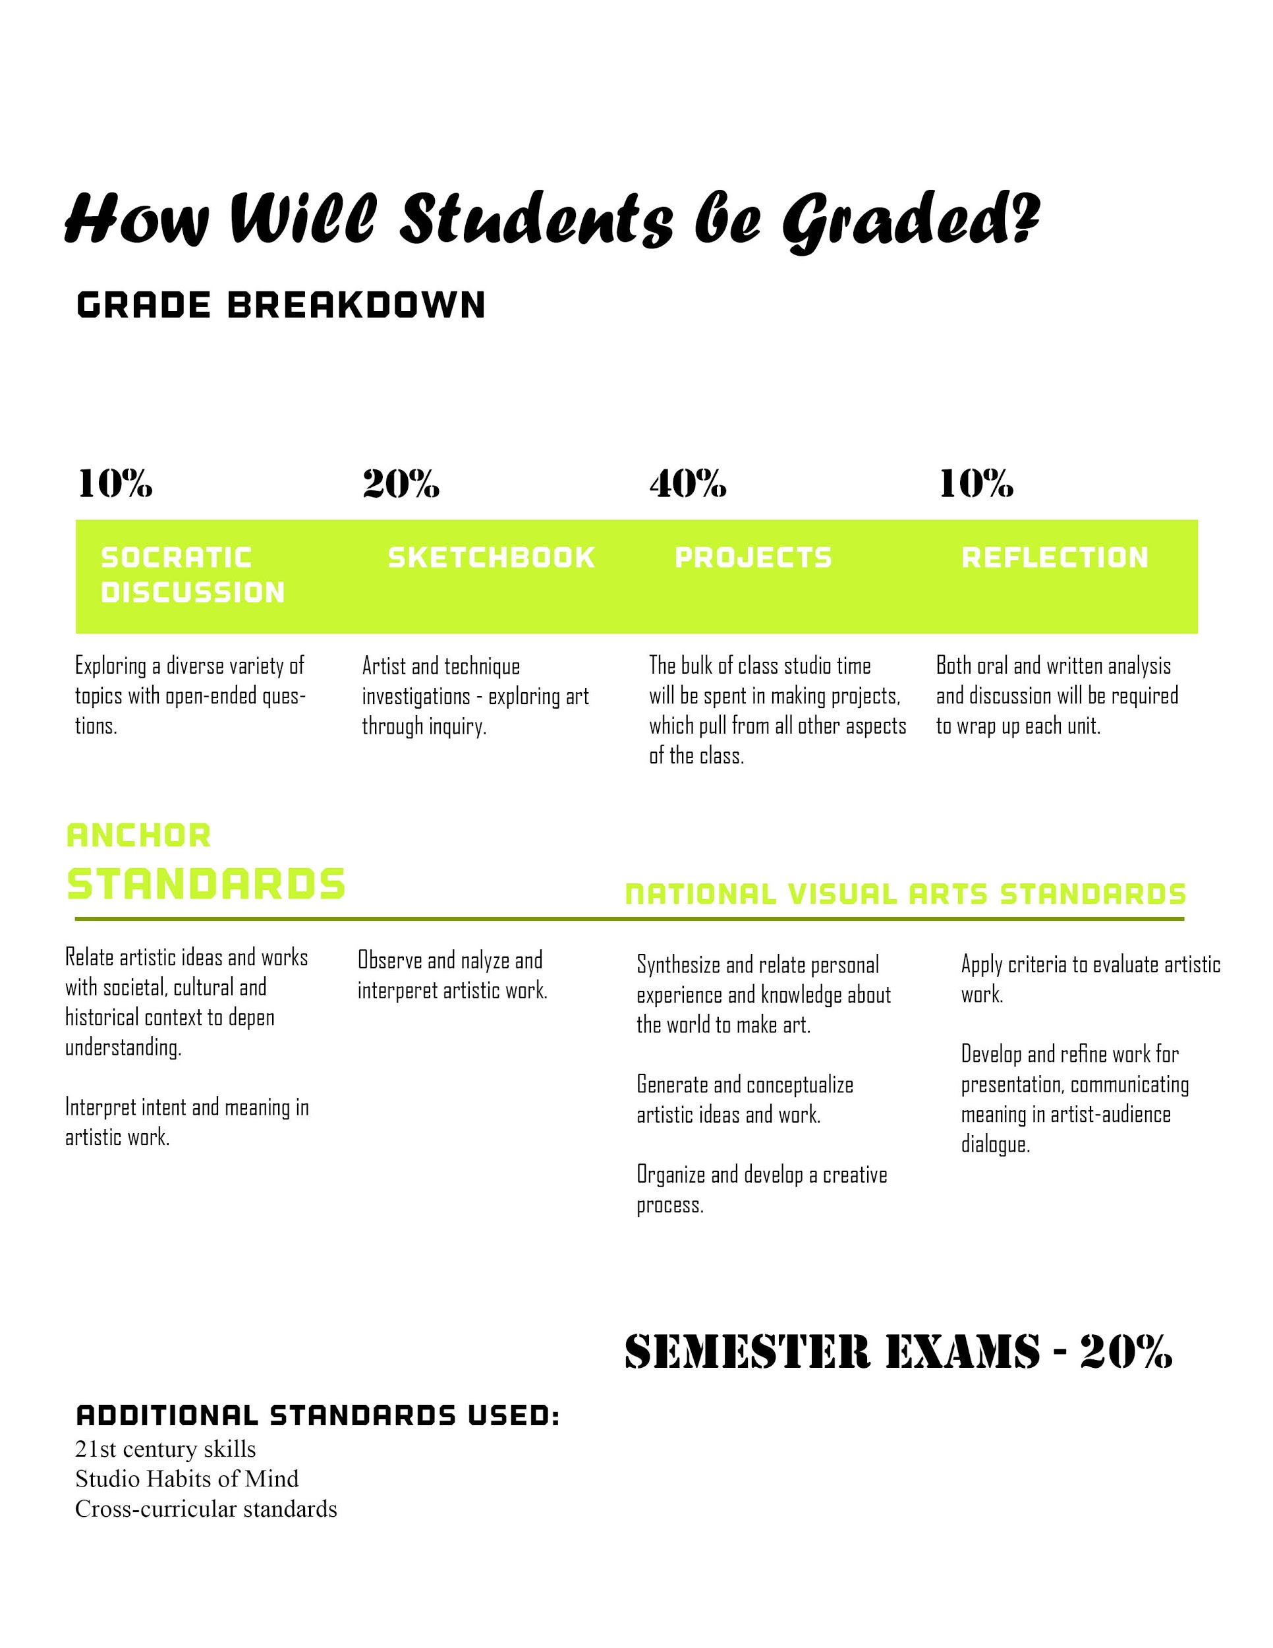

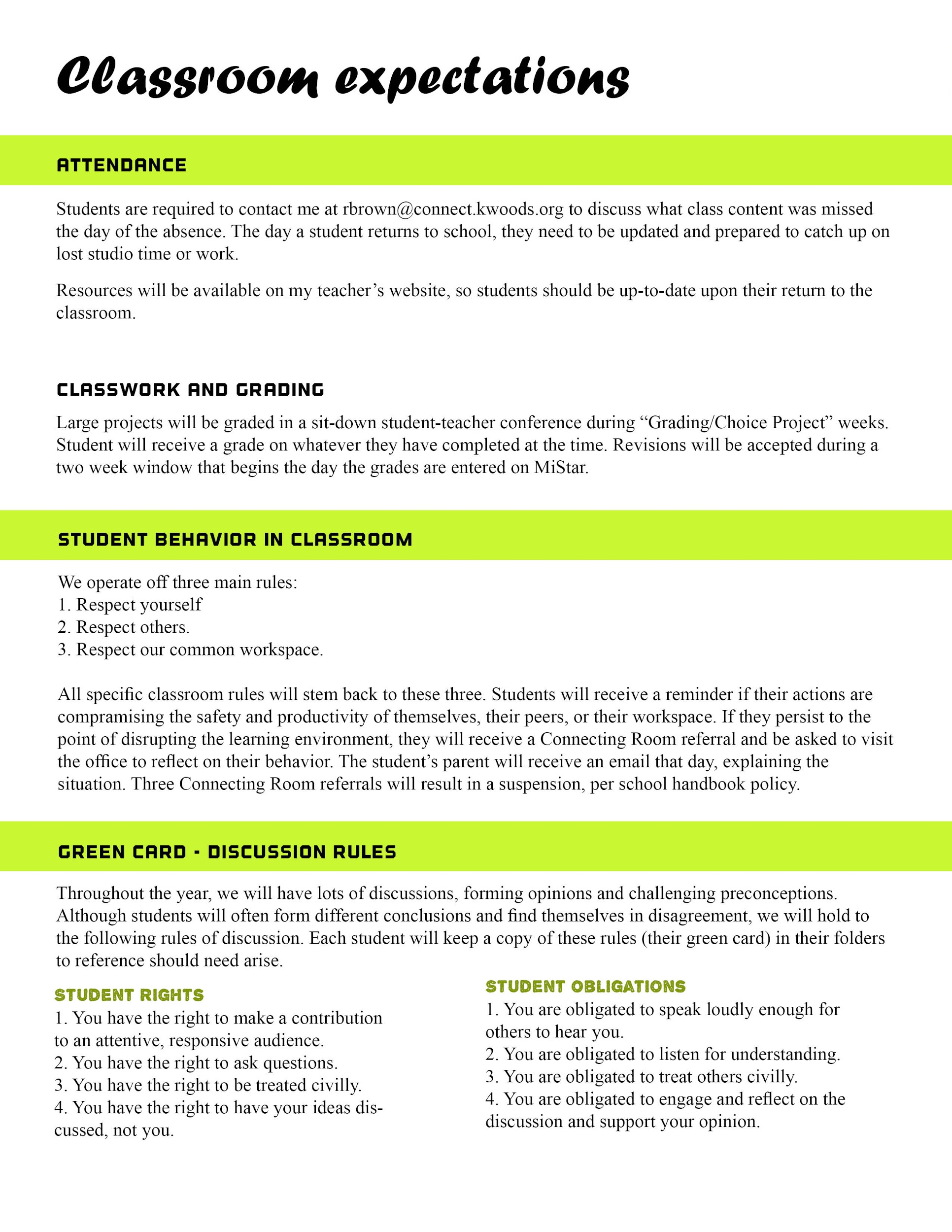

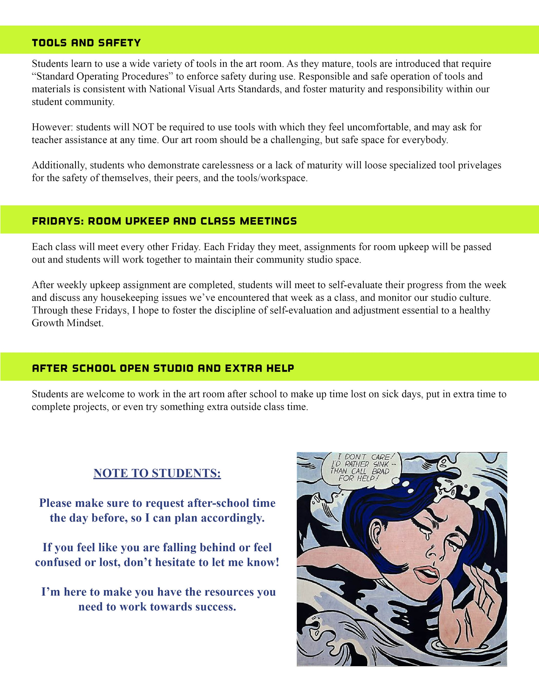Photo Credit: MOMA. Roy Litchenstein, Drowning Girl

Additional Classroom Expectations

Cell Phones/Mp3 players
Cell phones and mp3 players/music players are not allowed out during class without teacher permission. At times you may use them for music or research with teacher permission, but never during whole class or group activities. Both headphones should be out of the ear during whole class or group activities.

Being out of Class
Students are expected to be responsible about being out of class. Students may not leave class the first 15 minutes while the class is getting started. Students are asked to alert the teacher when they need to use the restroom but are asked not to leave class when whole class or group activities are in progress. Only one student is allowed to be out of the class at a time to use the restroom. If a student is out of class more than 15 minutes (unless they are with another teacher), it will result in an absence.

Computer Labs
There is absolutely no food or drink in the computer labs. While in class and in the labs, you are expected to follow all rules of the computer labs and your Computer Use Agreement.

File Storage
You will be able to store your project files on your Google Drive. We will review the options in class. You also have the option of using a USB drive, but forgetting your drive is not an excuse for not having your work.

Schedule

This is an overview of the year to give you an idea of what topics we will be covering. Please note that some things may change!

Most units contain multiple projects. All Units and majority of projects will include a critique and reflection. Critiques Reflections are completed using a variety of methods (including, but not limited to: writing, presentation, small group discussion, peer review, video, blogging)

All units will cover the following major skills and concepts:

- Creative Process  - Development of technical skills  - Reflection  (oral, written)  - Analyzing and critiquing work  - Justification of opinion | - Discussion  - Art History  - Art Context  - Learning about/from artists  - Communication of ideas  - Problem solving

Unit 1 – What is Art?
Media: Mixed
Skills Focus: Collaboration, Methods of Creative Development, Analysis/Synthesis

Unit 2 – Power of Creativity
Media: Collage, 3D Mixed Media
Skills Focus: 3D Craftsmanship, Composition, Visual Analysis, Deconstruction

Unit 3 – What is Reality?
Media: Drawing, Painting
Focus: Observation, Interpretation, Applying Criteria, Rendering Skills

Semester 1 Final Project and Reflection

Unit 3 – Identity
Media: Drawing, Painting, Mixed Media
Focus: Symbolism, Visual Storytelling, Synthesis, Figure/Gesture Drawing

Unit 4 – Abstraction
Media: Jewelry Making, 3D Printing
Focus: Cold fabrication Metalwork Techniques, Casting, Deconstruction, Abstraction

Unit 6 – Making a difference
Media: Ceramics
Focus: Social Justice, Construction/Fabrication, Form/Function

Unit 8 – Environment
Media: Furniture Design - 3D Design
Skills Focus: Construction/Fabrication, Design Thinking, Client-Based Design

Semester 2 Final Project and Reflection

I have read and reviewed the attached syllabus and agree to abide by it. I understand any questions may be directed via email to rbrown@kwoods.org.

Guardian Signature: _______________________ Date: _________________

Student Signature: ________________________ Date: _________________

Prefered Guardian Email: ________________________________________________________
- I would like to receive classroom updates and newsletters (through MailChimp), as well as regular updates on my student’s work (through Google Classroom).

