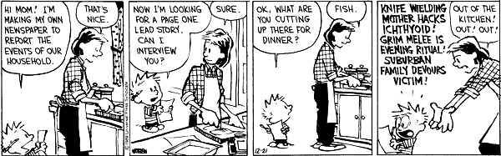
Desktop Publishing
Journalism Unit

Assignment 1:
Find an interview article featuring a person of your choice. Print the article and read through and complete the reading guide handed out in class. Additional copies of the reading guide will be available on my teacher’s website.
We will work on this assignment in-class on Sept. 22, and anything not finished in class will be homework.
Due: Wednesday, Sept. 23 – Turn in to basket.

Assignment 2:
Interview your partner (assigned in class on Sept. 21) using the interview guidelines provided. Take notes either by hand or by computer. After the information has been gathered, use the “Type of Leads” hand-out to create a strong, striking introduction, which will set the tone for the rest of your article.
We will be working on this assignment in class on Wed., Sept. 23. Anything not finished in class will be homework.
Due: Thurs., Sept. 24 to Art Drive (your name folder)

Assignment 3:
Final interviews will be typed up in Google Docs and should be a half-page in length at least. Please follow the “inverted pyramid” style of writing.
- Begin with the lead created in Assignment 2.
- Your article must be read over and approved by the interviewee.
We will work on this assignment in class on and Thurs., Sept. 24. Anything not finished in class will be homework.
Due: Monday, Sept. 28 – turned in to Art Drive (your name folder)

