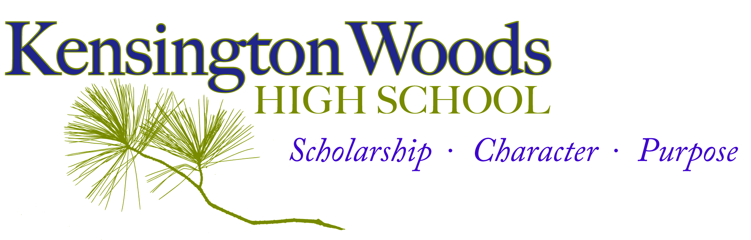

General Course Information
Course Title | Middle School Art 1
Description | The goal of Kensington Woods Middle School art curriculum is to create an environment where students experiment with image/object and meaning-making. Students will accomplish this through experimentation with a variety of 2D and 3D media, including traditional and digital. The main focus will be on building creativity skills and the understanding of the importance of communicating ideas through artwork, as well as practicing the creative process. Experimentation leads to passion, engagement and confidence in the arts. Through integrated projects, they will make connections through with the rest of the curriculum and the real world.
Room Number | 107
Faculty Name | Ms. Brown
Contact Information | rbrown@kwoods.org
Course website | rbrown.kwoods.org

Introduction

Why Art Education?
Art provides the opportunity to communicate ideas through a visual medium. Artists process their world around them and communicate their thoughts through their artwork, solving problems through imagery. In building our artistic skills, we work towards strengthening communicating our ideas, our visual (aesthetic) choices, our technique and our creative process.

Ms. Brown’s comment to students~ Welcome to our art classroom! I’m so excited to get rolling on the projects we have planned for this year; you’ll experience art from some fantastic people and develop a creative voice of your own. Don’t panic if you haven’t had much practice with art; just bring an open mind, enjoy the process, and the skills will come in time.
Extra help is available!
- We will have an “Art Support” Advisory for students who need extra help during the school day.
- After school help is also available Open Studio days, which will be posted on the art room door.

Prerequisite knowledge/skills for success in this course:
Students do not need to have prior art experience to find success in this course.

Instructor Expectations

Students will build their artistic skills, which will include techniques like drawing and painting, but also develop a unique visual voice. Although technical ability is important, we will place just as much importance on the problem-solving and conceptual thinking that takes place during the creative process. Projects will rotate between skills building and conceptual work, expanding students’ artistic toolbox with techniques, then synthesizing ideas in choice-based projects.

Students will also be expected to take initiative in the creative process, often making many decisions responsibility for the care and maintenance of art supplies for a safe and functional art room.

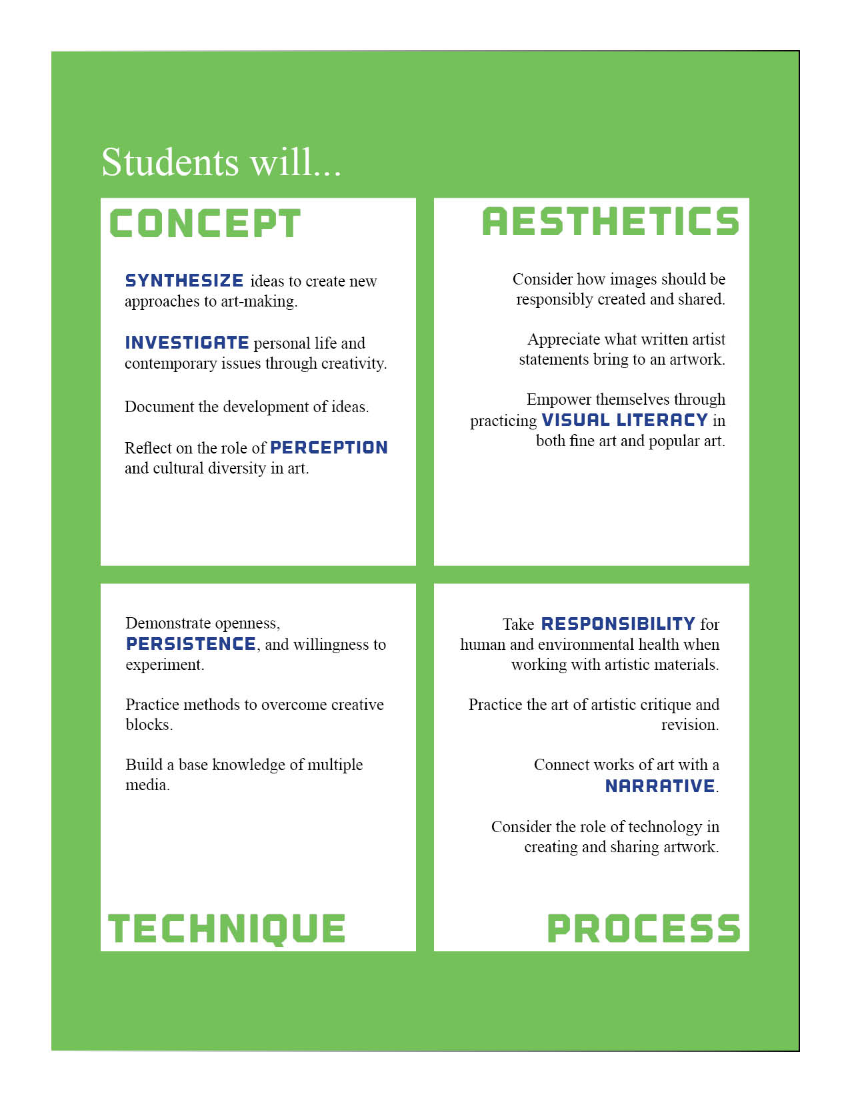
Essential Standards – Taken from the National Art Education Standards, these are the expectations for student learning, and will guide the portfolio process. It seems like quite a bit, but by the end of the semester, students will have built a body of artwork that reflects their learning in each of these categories:

Course Materials
Sketch/Notes Binder Required Daily
This is a three ring binder the students will make filled with loose leaf lined paper and copy paper. Students will be responsible for taking class notes and doing sketching and planning activities in their binder. These will play an important part in our larger projects and our creative process, along with our class-made sketchbooks.

Daily Assignment Policy
1. Sketchbook assignments will be done both in-class and out of class and will be essential to your final products! Any extra research or planning assigned will be directly applicable to your project.
2. Because our projects will depend on research and planning, those who do not complete their assignments will be unable to move forward with their projects. Files and assignments will be available on the art room website, and open studio time will be scheduled after school for those who need additional help or computer resources.
3. Considering most of our class content is taught through experiences in class, students who do not use their studio time productively may be asked to make up time before or after school, or at lunch. Students who neglect to make up time when requested will be placed on the Mastery List. This new art room policy aims to prevent students from falling behind studio work, which can be very difficult to make up at home.
3. It is the student's' responsibility to make sure that they find out what they missed during their absence. Students should check the class assignment calendar for a listing of the topic and assignment.

Note Regarding Choice-Based Summative Projects:

All our projects and units will be based around key Essential Questions that guide our media and theme choices. If students are interested in a particular media or topic outside the class project, they have the choice to present a project proposal form outlining a personal plan, providing it demonstrates exploration of the Essential Questions.

Since grading is rooted in self-evaluation and exploration of Essential Questions, students are free to pursue their individual interests, providing they demonstrate the initiative and dedication to research and write a solid project proposal.

Proposal forms and unit Essential Questions for the semester will be available online starting in October for students to download.

Classroom Expectations

- Classroom Expectations- Students should come to class ready to learn. Students should respect the learning environment, including the people and property around them. Students will not be allowed to have food or drink in the classroom (with the exception of water). Many projects will be in progress on the tables, and spills can be disastrous. If there is food brought in it will be taken away and the student can retrieve the items from Ms. Brown after class.

- Beginning of Class- Be on time and in your seat with all required materials. *** Binder/sketchbook, Assignments, Pencil, Paper***
At the beginning of class, students will complete Sketchbook Creativity Challenge (on the board) or follow directions as given. Students may not leave the room for the first 15 min. of class or during class discussions or directions. To use the restroom, a student will need to ask the teacher, and only one student will be permitted in the hallway at a time. A student who is out of the classroom for more than 15 min., unless with another teacher, will be marked absent.
- Class Assignments, Discussions, and Studio Time- Students will be expected to participate in classroom activities and to complete classroom assignments. Safety rules for materials use will be learned early and reviewed often, as well as the care and maintenance of studio supplies. Students will be responsible for the condition of their tools during studio; each will be assigned to a set for each class, and the maintenance of their tools will directly influence their portfolio quality.

- Technology- We will often use tech in class to supplement class discussions or research. Cell phones, however, should remain in pockets or bags unless instructed otherwise. Please review the handbook for consequences regarding improper cell phone use.

- Handing in Work- Students will keep their sketching assignments in their sketchbook/binder and turn in any typed or digitally-based assignment on their Google drive. We will review this process and practice during class.

- End of Class- Students are expected to return all materials to their designated places, complete their assigned team jobs, and return to their seats before being dismissed by the teacher. Students will be held accountable for their workspace; the room must be clean before class will be dismissed!

- Finding out Course Grade- Students will be given notification of their current grade average in the course at least one week before official progress reports, including an approximation of their current portfolio work. The approximation will not be an official grade, but a form of feedback. Final portfolio grades will be calculated at the end of the unit. Students may also make arrangements to see me outside of class to find out grade information. Time will not be taken out of class on a daily basis to discuss individual student grades.

- ICU- is a program that allows every student the opportunity to succeed and, therefore, increases student achievement. In the ICU program, every Kensington Woods student is expected to complete every assignment given by their teachers, providing them with the most opportunities for success. Students who do not complete their assignments (practice) or complete them with low quality will be placed on the ICU List and will be provided with extra opportunities to practice throughout the day.

Artsonia

This year, we will be building an optional digital portfolio on artsonia.com. This site is a great way for students to share their work with anybody they choose, either through a free digital gallery or ordering mugs, shirts, etc. featuring their artwork. Our art room receives a percentage of any sales made from the gift shop, which means more supplies! The school’s gallery will be publically open to browse, and students who opted to participate would receive a username combining their first names with numbers to protect their identity, and no photos of students or signatures are ever posted.

Please feel free to browse the site yourself.
http://www.artsonia.com/

All students who wish to participate in Artsonia must have the attached permission sheet filled out and returned to Ms. Brown before an account can be opened.

UNIT OVERVIEW
Below is an outline of our planned course for the year. Units may shift or alter to best fit integration, material availability, and time purposes.

Unit 1: About Face
Multimedia exploration of art in altering reality with imagination.
MEDIA: Photography, multimedia, digital art

Unit 2: Taking It to the Streets
Study of street art as a cultural expression of social justice and questioning.
MEDIA: Colored pencil, marker, machine embroidery, spray paint, multimedia

Unit 5: Way Back When
Understanding portraiture as storytelling and exploring the diverse effects of portraiture techniques across cultures.
MEDIA: Colored pencil, painting, plaster (and other casting materials), photography

Unit 3: Little-Big
Movement from large-scale ideas to finding inspiration in the everyday.
MEDIA: Painting, STEAM engineering, ceramics

Unit 4: Wearing Your Thoughts on Your Sleeve
Using jewelry-making techniques to create wearable statements.
MEDIA: Multimedia, 3-D

Unit 5: Independent Project

