DESKTOP PUBLISHING
Photo-Editing with Photoshop Name:

OPENING A FILE:
“File”>
Make sure to “Save As” right away!
Two reasons:

CROPPING A PHOTO
<<<This icon!
You should crop to the rule of _________________.
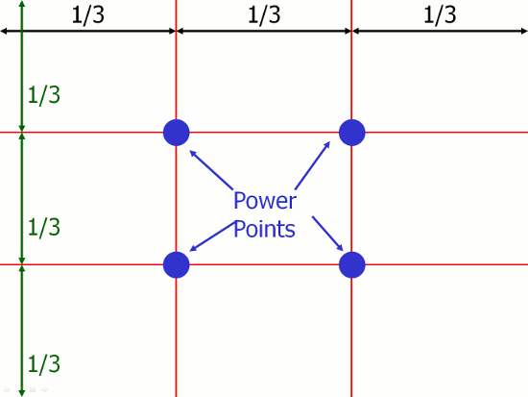from sixminutes.dlugan.com

Adjusting Values
This allows you to have the full range of darks and lights for a vibrant photo!
White point –
Black point -
Midpoint -
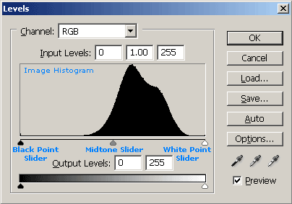 from cambridgeincolor.com

Readjust the ________________ to hit the black and white points according to the graph.
*See example in class*

Color Adjustment:
Hue-Saturation

Color Balance

Auto-Adjust Features
Try to avoid these, as they automatically pick points of adjustment but don’t always “understand” your photograph.

