Desktop Publishing
More Photoshop Tricks and Tips!
Name:_______________________________
Type Tool – for adding words.
- Click and drag to create a text box.
- To adjust font, highlight text and use the font menu at the top of the screen.
  - Quick scroll:

- You can also change the color with the “color picker” on the left toolbar.
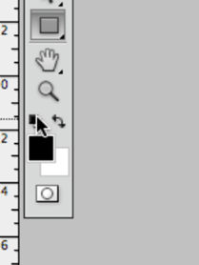

Selection Tools – To isolate certain things for spot work.
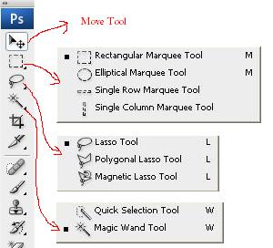
Marquee tool:

Magnetic Lasso:

Quick Selection:

Magic Wand:

Handy tips:
Quick “deselect”: Ctrl+D
Edit Selection

What you can do with a selected area:

New Layer

Filters

…And much more! Take notes on what you find to remember in the future:

