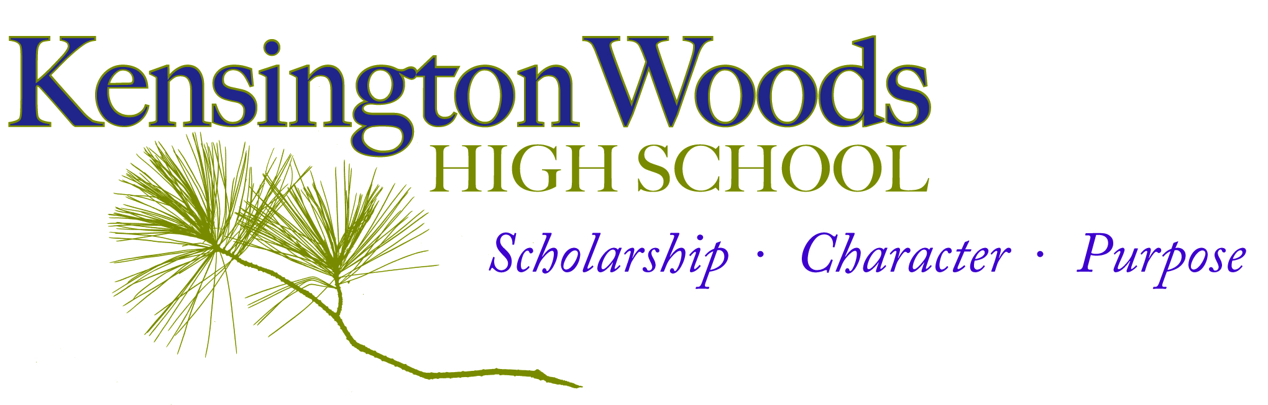

General Course Information
Course Title | Desktop Publishing
Description | The goal of Kensington Woods Desktop Media is to engage each student in an exploration of the graphic design and print media world, focusing on the power of quality photo and print journalism. Students will also learn to work as a team, dividing tasks and communicating to reach a larger goal: designing the school’s yearbook. Alongside the group project, students will be encouraged to pursue an independent project reflecting their specific interests in print media.
Room Number | 107
Faculty Name | Ms. Brown
Contact Information | rbrown@kwoods.org
Course website | rbrown.kwoods.org

Introduction

Yearbook at a Glance:
Kensington Wood’s yearbook elective plunges students into the world of print design, photo-journalism, and written journalism. Because it revolves around the design of a print publication, students will learn to work together as a team, sharing managerial responsibilities like a professional design team. From creating In-Design layouts to photo-editing to writing copy, students will develop the wide range of skills that go into design work.
Ms. Brown’s comment to students~ Hello Yearbook Design Team! This year, I will strive to bring you the full design experience, not only in creating a stellar yearbook, but in tying all we do to current career fields in design, finding your new favorite artists and building your own strengths and taste in graphic design. Bring your Growth Mindset to class each day, and we will create something spectacular together.
Extra help is available!
- We will have an “Art Support” Advisory for students who need extra help during the school day.
- After school help is also available Open Studio days, which will be posted on her teacher website.

Prerequisite knowledge/skills for success in this course:
Students do not need to have prior art experience to find success in this course.

Instructor Expectations

Yearbook is a class unlike any other, because students will be working together to build a single product. Missing deadlines or bringing half-finished work will affect the rest of the class and the final result. This class does not require any previous knowledge in design; I will teach you what you need to know. It is important, however, that you bring your best effort daily and be open to direction and feedback from the group. If we can all pledge to do this, our yearbook class can be a team experience unlike any other.

Essential Standards –Pulled from the National Art Education Standards and the ISTE Technology Standards, these are the expectations for student learning, and will guide the portfolio process. It seems like quite a bit, but by the end of the semester, students will have built a portfolio that reflects their learning in each point. Below is a list that will guide, but not limit, the curriculum.

Students will:
- Learn multiple approaches to begin creative endeavors.
- Communicate and collaborate with a variety of media.
- Contribute to project teams to produce original works and solve problems.
- Establish criteria to evaluate creative work.
- Document the process of developing ideas.
- Develop and apply effective organizational and time management skills independently and within a team setting.
- Create original works as a means of personal or group expression.
- Produce a final, marketable product through team effort.

Course Materials
Sketch/Notes Binder Required Daily
This is a three ring binder the students will make filled with loose leaf lined paper and copy paper. Students will be responsible for taking class notes and doing sketching and planning activities in their binder. These will play an important part in our larger projects and our creative process.
Thumb Drive Optional-but useful!
Students can bring a thumb drive to class to back up their work as they go and bring in images or fonts they find outside of class. Consider it a secondary, digital binder

Grading

Your semester grade will be determined as follows:  Formative Assessments.....0%  Summative Assessment.....90% Semester Exam.....10%  Formative Assessments-  Daily assignments & activities, planning sketches  Summative Assessments-  Sample project, job review, independent project | KWHS follows the following grading scale:  A = 95-100 (4.0)  A- = 90-94 (3.7)  B+ = 87-89 (3.3)  B = 83-36 (3.0)  B- = 80-82 (2.7)  C+ = 77-79 (2.3)  C = 73-76 (2.0)  C- = 70-72 (1.6)  F = below 70 (0.0)

Daily Assignment Policy
1. Students will be responsible for keeping track of both the class schedule and their independent assignments. We will review both weekly in class, and begin each day with a task assessment. Students will keep close track of what they accomplish each day in class to build time-management and organizational skills.
2. Because our yearbook outcome will depend on individual parts combined as a whole, missing assignments are not an option. Files and assignments will be available on the art room website, and open studio time will be scheduled after school for those who need additional help or computer resources. Students with late or missing work will attend ICU.
3. It is the student's' responsibility to make sure that they find out what they missed during their absence. Students should check the class assignment calendar for a listing of the topic and assignment.
Summative Assessments
- Sample Project~ At the beginning of the year, students will create a sampling of all the skills they will be asked to choose from for their yearbook role. This will ensure an informed decision, and also create an understanding of the process as a whole. Our initial magazine spread will focus on a class member and include a formal interview, photos, captions, and standard layout. Rubrics will be provided, and both teacher and peer critique will be provided for the opportunity of maximum mastery.

- Team Job Review – Students will also be evaluated on their role as a design-team member. Duties will be clearly outlined and signed as the jobs are divided, and students will be assessed on the tracking and fulfillment of said duties.

- Independent Project~ Towards the end of the year, students will have an opportunity to plan and create a graphic design project of their choosing. Rubrics will also be provided to structure the project and outline the grading procedure.

Classroom Expectations

- Classroom Expectations- Students should come to class ready to learn. Students should respect the learning environment, including the people and property around them. Students will not be allowed to have food or drink in the media center, although closed drinks will be permitted in the classroom. Any food brought in will be taken away and may be retrieved from Ms. Brown after class.

- Beginning of Class- Be on time and in your seat with all required materials. *** Binder/sketchbook, Assignments, Pencil, Paper***
At the beginning of class, students will log their daily objectives in their binder or follow directions as given. Students may not leave the room for the first 15 min. of class or during class discussions or directions. To use the restroom, a student will need to ask the teacher, and only one student will be permitted in the hallway at a time. A student who is out of the classroom for more than 15 min., unless with another teacher, will be marked absent.
- Class Assignments, Discussions, and Studio Time- Students will be expected to participate in classroom activities and to complete classroom assignments. Computer use will be focused on yearbook work; students will be expected to responsibly use computer time as directed.

- Technology- We will often use tech in class to supplement class discussions or research. Cell phones, however, should remain in pockets or bags unless instructed otherwise. Please review the handbook for consequences regarding improper cell phone use.

Digital cameras will also be used in the production of the yearbook. Please review our official handbook regarding student responsibility for school equipment.

- Handing in Work- Students will keep their sketching assignments in their sketchbook/binder and turn in any typed or digitally-based assignment on their Google drive. We will review this process and practice during class.

- End of Class- Students are expected to return all materials to their designated places, complete their assigned team jobs, and return to their seats before being dismissed by the teacher. Students will be held accountable for their workspace; the room must be clean and students seated before class will be dismissed.

- Finding out Course Grade- Students will be given notification of their current grade average in the course at least one week before official progress reports, including an approximation of their current work. The approximation will not be an official grade, but a form of feedback. Final design grades will be calculated at the end of the unit. Students may also make arrangements to see me outside of class to find out grade information. Time will not be taken out of class on a daily basis to discuss individual student grades.

- ICU- is a program that allows every student the opportunity to succeed and, therefore, increases student achievement. In the ICU program, every Kensington Woods student is expected to complete every assignment given by their teachers, providing them with the most opportunities for success. Students who do not complete their assignments (practice) or complete them with low quality will be placed on the ICU List and will be provided with extra opportunities to practice throughout the day.

Schedule

On the next page, students will find an outline of the topics that will be covered in this course. Please keep in mind that this timeline may need to be adjusted from time to time to best meet the needs of the class. The schedule will also be available online with current updates.

Students: please read this syllabus over with your guardian and return this sheet with both signatures.

____________________________________________________________________________

I agree that I have read, understand, and agree to the guidelines set forth for Desktop Publishing.

Student Name:_____________________ Guardian Name:________________________

Student Signature:__________________ Guardian Signature:________________________

Date:__________________ Date:__________________

Any additional notes or comments to me:

